Identification de l’incident :

|  |  |  |  |
| --- | --- | --- | --- |
| **De :** | Agnes MAZAS |  |  |
| **Date** | 23/01/2020 | | |
| **Classification** | •MAM : Generated Audit / Manual Audit | | |
| **Reproductible : Yes** | | | |
| **Version IE** : IE 11.0.9600.18860CO | | | |
| **Version client 3D :** (Connexion au client 3D : touche shift+Ctrl+v) : VDC5.6.4. MAM.01.19.2020 | | | |

Steps to reproduce :

# Problem

Following case 26 (When validate a Generated Audit is needed to be validated in another Generated Audit because of the use of the same rack), it is possible to validate Generated Audit unless another Generated Audit is validated. Then, even if all Generated Audits concerning this rack are completed, this rack is no more available in list when creating new audit.

# Steps to reproduce

We have two Generated Audit [WO AMA Move 27]_[158543] and [WO Install Srv BL 81]_[158477].

Both are concerning servers in the same rack V3-G-07.

## Open generated audit A : [WO Install Srv BL 81]_[158477]

## Go to Rackmount Assets tab and validate server Srv_AMA_Move_2

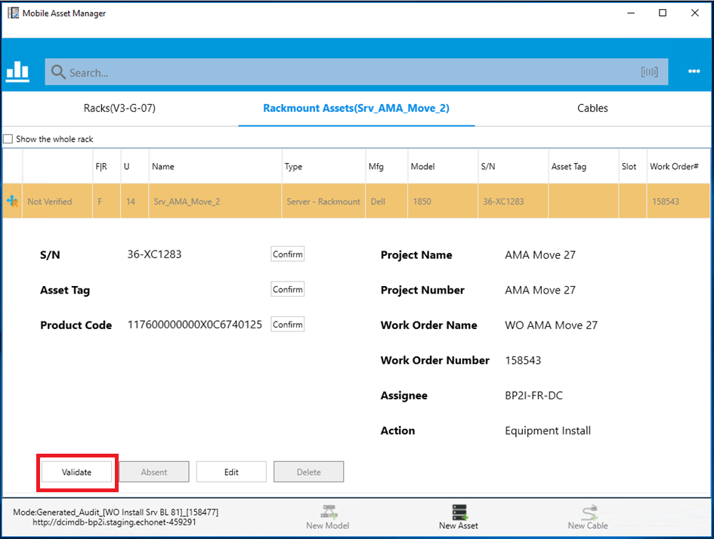

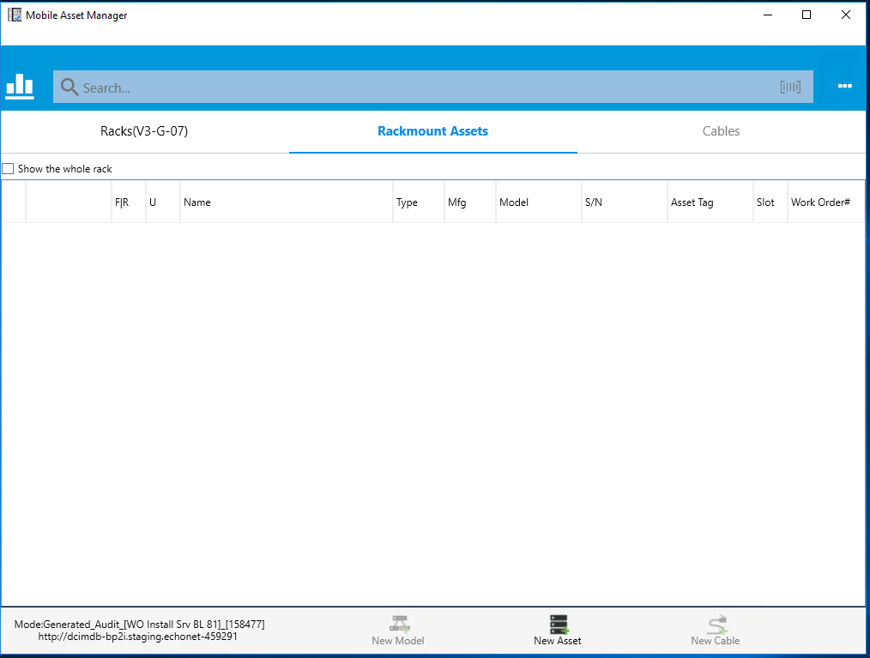

First, Generated Audit [WO AMA Move 27]_[158543] is completed :

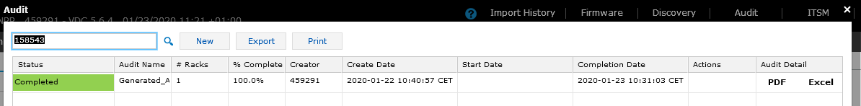

## Go to Rack(V3-G-07) tab

Validate rack V3-G-07:

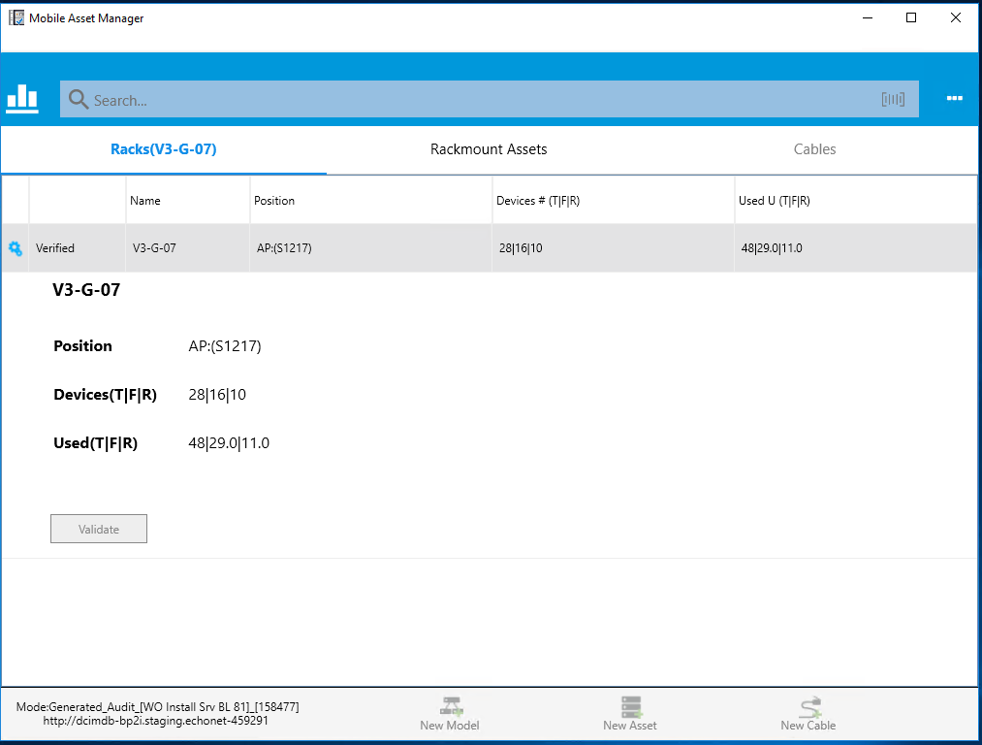

Finally, Generated audit [WO Install Srv BL 81]_[158477] completed :

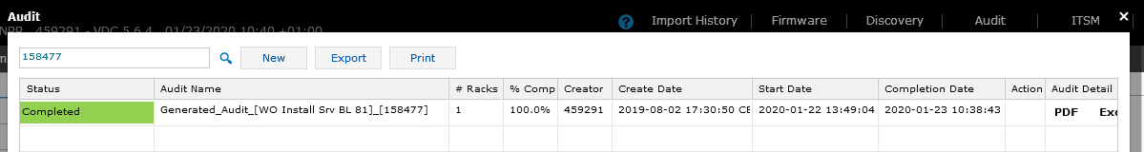

## Try to create a new audit on this rack

Rack V3-G-07 is not available in list

